SIMATS ENGINEERING
Department of Information Technology
DATA STRUCTURES

————————————————————————————————————————

ASSIGNMENT 1 – CO1
Design, Analyse and Validate Data Structures for a Smart Parking Management System
CO1: Understand the abstract properties of various linear and non-linear data structures such as Stacks, queues, lists, trees and graphs.

Student Name | K.Teja Sri | Register Number | 192525249
Department  / Section | AIML | Academic Year  / Semester
Faculty Name | Dr. Supriya L P | Nature of  Assignment | Individual
Duration | 1 Week | Total Marks | 50
Date of Submission |  | Date of Evaluation

————————————————————————————————————————

MARK SHEET (Rubric-based Evaluation)

Task | Task Title | Max | Marks Awarded | Remarks
1 | Understand the Problem; Identify Data and Operations |  |  | Entities, relationships, operations with frequency and speed needs, and correctness rules identified. m-copies vs shared ADT compared.
2 | Classify the Data Structures |  |  | Primitive vs non-primitive, linear vs non-linear, static vs dynamic justified. Flat array, 2-D array and per-level access compared.
3 | Define and implement an ADT (SlotList) |  |  | Operations with pre/post conditions; correct insert/delete/print; boundary tests; array vs linked list; .h/.c separation.
4 | Analyse Array Storage |  |  | Address formulas with worked examples; predicted output reasoned step by step; array kinds and parameter decay; O(n) middle insert/delete and doubling.
5 | Analyse Recursive Solutions |  |  | Output predicted with trace; recurrences for show and mystery; 11 vs 19 calls; stack space and loop comparison.
6 | Count the Steps of an Algorithm |  |  | Step counts for four loops (136, 4, 64, 4) derived; notation explained; growth table; maintained free count.
7 | Analyse Best, Average and Worst Cases |  |  | Conditions, counts and reasons for every case; average (n+1)/2 derived; binary search needs sorted data; O(n) cost to keep order.

8 | Analyse Space Complexity |  |  | int array vs bitmap bytes calculated; recursion stack space compared; sizeof confirmed.
9 | Implement and Test the Parking Data Structures |  |  | Working init/park/leave/lookup with maintained count; tests for full, empty, first/last slot and 10-event sequence; expected vs actual output.
10 | Compare Theory with Measurement |  |  | Same compiler flags and repetitions; real (not invented) timings; measured growth compared with Θ(n); counting vs clock() discussed.
11 | Recommend and Defend the Final Design |  |  | Design for 80,000 slots with each component justified; operation complexities; load factor ≈ 106,667 buckets; trade-offs; evidence-based defence.
12 | Re-evaluate and Adapt the Design |  |  | Impact of EV, nearest-slot and monthly-pass requirements; O(n) scan evaluated; revised function tested; index trade-offs; no unmeasured claims.
 | TOTAL |  |  | Percentage : 93.5

OVERALL REMARKS
Excellent analysis of the Smart Parking Management System, demonstrating a clear understanding of data structures, ADT implementation, array storage, recursion, time and space complexity, and algorithm analysis. The assignment covers all 12 tasks, with practical implementation, boundary testing, complexity comparisons, and an evidence-based final design. Tasks 11–12 effectively demonstrate design justification and adaptation to new requirements. Areas for improvement include providing complete implementation code, actual measurement results, detailed test outputs, and consistent cross-referencing. Overall, the work demonstrates strong analytical and problem-solving skills, with scope to improve implementation completeness and experimental validation.

Student Signature | Faculty Signature | Program Director

MANDATORY SUBMISSION EVIDENCE CHECK
✓ = present ✗ = missing / not satisfied P = partly present. Based on the "Evidence Expected" of each task. Figures and screen outputs are referenced in the report but are not present in the submitted text copy.

Task | Evidence Expected | Statu | Note
1 | Problem definition, entities and relationships, operations, frequency requirements, correctness rules, and shared ADT versus independent copies. | ✓ | All major requirements are identified; ensure the design strategy and its justification are clearly presented.
2 | Classification of primitive/non-primitive, linear/ non-linear, static/dynamic data structures; comparison of flat arrays, 2-D arrays and per- | P | Introduction is duplicated. Remove repetition and ensure all classifications and comparisons are clearly justified.

3 | ADT specification, preconditions and postconditions, C implementation of init, insert, delete and print, boundary tests, and .h/.c | ✓ | Verify that implementation code, interface files and boundary-test outputs are included in the submission.
4 | 1-D and row-major 2-D array address calculations, worked examples, output prediction, array parameter decay, insertion/deletion complexity and dynamic resizing. | ✓ | Ensure all address calculations and predicted outputs include step-by-step explanations.
5 | Recursive output traces, recurrence relations, complexity analysis of show and mystery, linear versus split count_free, and stack-space | ✓ | Recurrence solutions and call-count comparisons should be supported by clear derivations and traces.
6 | Step counts for four loops, derivation of operation counts, explanation of O, Ω and Θ, growth table, and maintained free-count analysis. | P | Verify the stated step counts (136, 4, 64 and 4) and include the growth table for all specified input sizes. Check the reference to S(n) in Task
7 | Best-, average- and worst-case analysis, comparison counts, average-case derivation, binary-search requirements and the cost of | P | Remove cross-references to missing content and provide complete solutions, mathematical justifications and interpretations.
8 | Array-versus-bitmap memory calculations, recursion stack-space analysis, bit-operation complexity, sizeof verification, and working Python implementation with C cross-check. | P | Python source code is missing and placeholders such as CPU model and RAM remain unfilled. Include complete code and reproducible test evidence.
9 | Working parking-system implementation, init, park, leave_slot and lookup, free-count invariant, boundary tests, ten-event sequence,  expected-versus-actual outputs and complexity  analysis. | P | Include complete program output, test results and visible graphs where referenced. Ensure the implementation follows the design specified in Task 1.
10 | Repeated performance measurements, compiler flags, actual timing tables, comparison with theoretical growth, and discussion of operation counting versus clock(). | ✓ | Retain actual measured results and explain any differences between theoretical and observed performance. Remove outdated or stray references, including references to Table 1b and Sections 3–4 where they do not exist.
11 | Recommended design for 80,000 parking slots, component justification, operation complexities, hash-table sizing at load factor 0.75, alternative comparisons and experimental evidence. | ✓ | The final design is evidence-based. Reconcile the hash build-cost discrepancy (12.3n versus 2n) and ensure the hash example uses the designed hash function rather than an inconsistent k mod 11 example.
12 | Analysis of EV charging, nearest-slot allocation and monthly passes; evaluation of the original design; revised implementation and tests; heap/ index trade-offs; evidence-based defence. | ✓ | All four aspects are addressed. Ensure the revised implementation is tested and all cross-references point to existing content.

IMPLEMENTATION EVIDENCE CHAIN (Tasks 8–9)

Evidence item | Status | Observation
Source code | P | Task 9 rubric requires working init, park, leave_slot and lookup operations. Confirm that the complete implementation and test code are included; the mark sheet alone does not establish that the source files are attached.

Test inputs | P | Required tests include full and empty parking states, first and last slots, and a ten-event sequence. Include the exact input/event sequence in the submitted report.
Expected behaviour | ✓ | Expected behaviour is specified through boundary tests, the maintained free-count invariant, and expected-versus-actual output comparison.
Actual output | P | Task 9 expects expected-versus-actual output. Ensure the actual console output or screenshots are included wherever referenced.
Intermediate algorithmic evidence | ✓ | The rubric calls for address calculations, recursion traces and call counts, loop step counts, complexity comparisons, and free-count analysis across Tasks 4–8.
Boundary / failure tests | P | The rubric explicitly requires full-list, empty-list and invalid-position tests for the SlotList ADT, plus full/empty parking states and first/last slot tests for the parking implementation. Show their results.
Interpretation | ✓ | Tasks 5–8 require recurrence, complexity, step-count and space analyses; Tasks 10–12 require interpretation of measurements and evidence-based design
Code, data and report consistent | P | Task 8 in the rubric focuses on array-versus-bitmap memory and stack space; Tasks 9–12 cover implementation, measurement and design evaluation. Check that every described program, test, table and figure is present and consistent with

SUBMISSION CHECKLIST (not separately marked)

Requirement | Status |  |  | Note
All 12 tasks (Tasks 1–12) answered | ☒ Yes | - Partly | - No | The mark sheet lists all 12 tasks.
Problem definition and data-structure classifications (Tasks 1–2) | ☒ Yes | - Partly | - No | Entities, operations, classifications and array representations are specified in the rubric.
ADT specification, implementation and boundary tests (Task 3) | - Yes | ☒ Partly | - No | Confirm the submitted code, .h/.c separation and test outputs are present.
Array calculations and worked examples (Task 4) | ☒ Yes | - Partly | - No | Address formulas, output prediction and insertion/deletion complexity are required.
Recurrence derivations and call-stack traces (Task 5) | ☒ Yes | - Partly | - No | Include the traces and derivations described in the rubric.
Step counts and growth table (Task 6) | ☒ Yes | - Partly | - No | The rubric specifies four loop counts and growth values for n = 200, 2,000 and 80,000.
Best, average and worst-case analysis (Task 7) | ☒ Yes | - Partly | - No | Include comparison counts, average-case derivation and binary-search conditions.
Space-complexity calculations and sizeof check (Task 8) | - Yes | ☒ Partly | - No | The rubric requires 320,000 B for an 80,000-int array versus 10,000 B for a bitmap, plus stack-space analysis and a target-compiler sizeof check.
Working parking implementation and test outputs (Task 9) | - Yes | ☒ Partly | - No | Provide implementation, free-count invariant, required tests,  expected-versus-actual output, and clean compilation evidence.
Actual measurement tables and theory comparison (Task 10) | - Yes | ☒ Partly | - No | The rubric requires repeated real timings and a reasoned comparison with theoretical growth.

Final design justified by analysis and evidence (Task 11) | ☒ Yes | - Partly | - No | Include operation complexities, load-factor sizing, trade-offs and evidence-based defence.

Requirement | Status | Note
Adaptation to new requirements (Task 12) | ☒ Yes ☐ Partly ☐ No | Address EV charging, nearest-slot allocation, monthly passes, revised code/ tests and heap/index trade-offs.
Every referenced figure, table and output is included | - Yes ☒ Partly ☐ No | Cross-check the report for missing screenshots, graphs, tables and stale references.
Code, input data, output and written analysis agree | - Yes ☒ Partly ☐ No | Reproduce results from the submitted implementation and ensure the report uses the same design and test cases.

DATA STRUCTURES

ASSIGNMENT 1 – CO1

CO1: Understand the abstract properties of various linear and non-linear data structures such as Stacks, queues, lists, trees and graphs

Nature of Assignment : Individual
Duration : 1 Week

Total Marks : 50
Submission Date :

Assignment Title: Smart Parking Management System (50 Marks) Duration: 1 week

Design Challenge:

A university library holds 150,000 book copies spread across multiple floors, sections, shelves and racks. The system must support issuing and returning books, looking up a book by its ID, tracking available and borrowed copies, maintaining a waiting list when a requested book is already issued, and responding efficiently as the collection grows over the years.

Design and evaluate appropriate data structures for the Smart Library Management System. Analyse storage representation, operation costs, recursion, time and space complexity, and performance using the methods and experiments specified in Tasks 1-10. Compare arrays, dynamic arrays and linked lists for storing book records, and justify the choice of structures for the member borrowing lists, the reservation queue and the transaction history. Evaluate linear and binary search for book lookup, including the cost of keeping the records sorted, and implement recursive and iterative versions of the key operations to compare their call stack usage and space requirements. Back your theoretical analysis with performance experiments in C on datasets of increasing size and different orderings, and explain any difference between the predicted and measured results.

Finally, recommend and defend a suitable design for 150,000 copies, then re-evaluate it when new requirements are introduced: priority reservations for faculty and research scholars, search by title, author or subject as well as by ID, and overdue fine tracking in which the most overdue records must be retrieved first. Determine whether the original design should be retained, modified or redesigned, and justify the decision using analysis and evidence.

Task 1 – Understand the Problem and Identify the Data and Operations (4 Marks)
1.1 Introduction
The Smart Parking Management System (SPMS) is designed to manage a large parking facility efficiently. It stores parking slot details, vehicle information, and availability status. The system helps users find available slots, park vehicles, release occupied slots, and check parking information.
1.2 Data to be Stored
S.No. | Data | Description
1 | Slot ID | Unique identification number for each parking slot
2 | Level ID | Identifies the parking floor or level
3 | Slot Status | Indicates whether the slot is free or occupied
4 | Vehicle Number | Registration number of the vehicle
5 | Vehicle Type | Car, bike, or electric vehicle
6 | Entry Time | Time when the vehicle enters
7 | Exit Time | Time when the vehicle leaves
8 | Parking Ticket | Ticket details given to the vehicle
9 | Parking Charge | Amount calculated for parking
10 | Monthly Pass | Details of registered monthly parking users
1.3 Operations Performed
S.No. | Operation | Description | Frequency
1 | Park Vehicle | Assigns an available slot to a vehicle | Very High
2 | Release Vehicle | Makes a slot free when a vehicle leaves | Very High
3 | Search Vehicle | Finds a vehicle using its registration number | High
4 | Check Availability | Displays the number of free slots | Continuous
5 | Display Slot Details | Shows slot number and its status | Medium
6 | Update Slot Status | Changes a slot from free to occupied or vice versa | Very High
7 | Calculate Parking Fee | Calculates the parking charge | High
8 | Find Nearest Slot | Finds the nearest available parking slot | High

1.4 Correctness Rules (Invariants)
The following rules must always be maintained:
- A parking slot must not be assigned to more than one vehicle.
- An occupied slot must contain valid vehicle information.
- A free slot must not contain an active vehicle.
- The total number of slots must remain 80,000.
- The free-slot count must always be accurate.
- A vehicle must be released only from its assigned slot.
1.5 Relationships Between Data
- One parking facility contains multiple parking levels.
- Each level contains multiple parking slots.
- Each parking slot can hold only one vehicle at a time.
- Each vehicle is assigned a parking ticket.
- A parking ticket stores entry time, exit time, and parking charges.
- A monthly pass is linked to a registered vehicle or user.
Relationship:
Parking Facility
Parking Levels
Parking Slots
Vehicles and Parking Tickets

1.6 Speed Requirements

Operation | Required Performance | Reason
Access slot by ID | O(1) | Direct array indexing
Park or release vehicle | O(1) for slot update | Frequent operations
Search vehicle | O(1) average | Fast vehicle identification using hashing
Check free slots | O(1) | Use a maintained counter
Find nearest free slot | O(1) to get the nearest candidate | Use a suitable priority structure

1.7 Shared ADT vs Multiple Copies
An Abstract Data Type (ADT) defines the operations and rules for managing data.

Shared ADT | Multiple Independent Copies
One common data structure is maintained. | Different copies of parking data are maintained.
All operations update the same data. | Copies may contain different information.
Prevents inconsistent slot information. | May cause incorrect availability counts.
Easier to maintain and test. | Difficult to synchronize.
Decision: A shared ADT is preferred because all users and system modules must access the same updated parking information. It helps prevent double allocation and incorrect free-slot counts.

1.8 Conclusion
The Smart Parking Management System requires efficient data structures to manage 80,000 parking slots. Arrays provide fast slot access, hash tables support vehicle searching, and heaps can help identify the nearest available slot. A shared ADT maintains consistency and improves reliability.

TASK 2 – Classify the Data Structures (3 Marks)
2.1 Introduction
Data structures are used to store, organize, and manage data efficiently. In the Smart Parking Management System, different data structures are selected based on the type of information and operations performed.
Data structures are mainly classified into:
- Primitive and Non-Primitive Data Structures.
- Linear and Non-Linear Data Structures.
- Static and Dynamic Data Structures.
2.2 Primitive and Non-Primitive Data Structures
Primitive Data Structures: These are basic data types that store single values.
Examples:
- int – Stores slot ID and level number.
- char – Stores vehicle registration characters.
- float – Stores parking charges.
- double – Stores precise numerical values.
Non-Primitive Data Structures: These store collections of values or relationships between data.
Examples:
- Arrays
- Linked Lists
- Queues
- Hash Tables
- Trees
- Heaps

2.3 Classification of Data Structures Used
Data Structure | Classification | Application in Parking System
Array | Linear, Static | Stores parking slot information
Dynamic Array | Linear, Dynamic | Stores slots with runtime capacity
Linked List | Linear, Dynamic | Maintains a list of available slots
Queue | Linear | Manages vehicles waiting at the entrance
Hash Table | Non-Linear / Indexed | Searches vehicle registration numbers
Tree | Non-Linear | Represents parking facility hierarchy
Heap | Non-Linear | Finds the nearest available parking slot
2.4 Linear and Non-Linear Data Structures
Linear Data Structures:
Elements are arranged sequentially, one after another.
Examples:
- Array
- Linked List
- Queue
Non-Linear Data Structures:
Elements are arranged in hierarchical or interconnected relationships.
Examples:
- Tree
- Heap
- Hash Table
In the parking system, the hierarchy of Parking Facility → Levels → Slots can be represented using a tree.
2.5 Static and Dynamic Data Structures
Static Data Structure | Dynamic Data Structure
Size is fixed. | Size can change during execution.
Memory is allocated in advance. | Memory is allocated when required.
Example: Static Array. | Examples: Linked List and Dynamic Array.
May waste memory if capacity is too large. | Uses memory according to requirements.
Static Array Example:
int slots[100];
Dynamic Array Example:
int *slots;
slots = (int *)malloc(100 * sizeof(int));
2.6 Comparison of Array Representations
The parking facility contains 80,000 slots distributed across multiple levels. Different array representations can be used to store the slot information.
A. Flat Array
A flat array stores all parking slots in a single-dimensional array.
int slots[80000];
- All slots are stored sequentially.
- Direct access is possible using an index
- Access time is O(1).
- Simple and memory-efficient when levels have equal capacities.
B. Two-Dimensional Array
A two-dimensional array represents parking levels and slots.
int slots[5][100];
- Rows represent parking levels.
- Columns represent parking slots.
- Access is performed using two indices.
- Access time is O(1).
- Suitable when every level has equal capacity.
C. Array of Per-Level Dynamic Arrays
Each parking level has a separate dynamically allocated array.
int *level[5];

for (int i = 0; i < 5; i++)
{
level[i] = (int *)malloc(100 * sizeof(int));
}
- Each level has its own array.
- Different levels can have different capacities.
- Memory can be allocated according to requirements.
- Access time is O(1) using level and slot indices.
2.7 Comparison of Array Representations
Representation | Access Time | Handles Unequal Levels? | Advantages
Flat Array | O(1) | No, without additional mapping | Simple and cache-friendly
2-D Array | O(1) | No | Easy to understand and manage
Per-Level Dynamic Arrays | O(1) | Yes | Flexible memory allocation
Tree | O(depth) | Yes | Represents hierarchy naturally
Example of Flat Array Indexing
Assume each level contains 400 parking slots.
To access Level 2, Slot 15:
[ Index = (Level \times SlotsPerLevel) + Slot \]
[ = (2 times 400) + 15 ]
[ boxed{Index = 815} ]
Therefore, Level 2, Slot 15 is accessed using index 815 in the flat array, assuming zero-based indexing.
2.8 Conclusion
Primitive data types store basic information, while non-primitive data structures organize large amounts of parking data. Arrays provide fast access to parking slots, linked lists support dynamic storage, queues manage waiting vehicles, hash tables support vehicle searching, and trees or heaps help manage hierarchical and priority-based information.Final Recommendation: A flat array is suitable when all parking levels have equalcapacity. If different levels have different capacities, per-level dynamic arrays are more flexible.

TASK 3 – Define and Implement an Abstract Data Type (ADT) – SlotList (5 Marks)
3.1 Introduction
An Abstract Data Type (ADT) is a logical description of data and the operations that can be performed on it. It explains what operations are performed, not how the data is stored in memory.In the Smart Parking Management System, we use an ADT called SlotList to store and manage the ordered IDs of available parking slots.

3.2 Difference Between ADT and Data Structure
ADT | Data Structure
Describes what operations are performed. | Describes how data is stored.
Logical representation. | Physical implementation.
Defines values and operations. | Uses arrays, linked lists, etc.
Example: SlotList. | Example: Array implementation of SlotList.

3.3 Why Do We Use SlotList ADT?
- Information Hiding: Users access data through defined operations.
- Reusability: The same ADT can be used in different modules.
- Easy Maintenance: The implementation can be changed without changing the operations.
- Consistency: Helps maintain correct parking slot information.
- Testing: Each operation can be tested separately.
3.4 SlotListADT Specification
The SlotList stores a sequence of available parking slot IDs.
Assume the capacity is 8.
Operatin | Function | Precondion | Postcondition | Return
Initialize | list_init() | List must exist | List becomes empty | None
Insert | list_insert() | Valid position and list not full | Adds a slot ID at the given position | 1 or 0
Delete | list_delete() | Valid position | Removes the slot ID | 1 or 0
Print | list_print() | None | Displays all elements | None
Size | list_size() | None | Returns number of elements | Size

3.5 Array Representation
The SlotList can be implemented using an array.
#define CAPACITY 8

typedef struct
{
int data[CAPACITY];
int size;
} SlotList;
Here:
- data[] stores available parking slot IDs.
- size stores the current number of elements.
- CAPACITY represents the maximum number of elements.
3.6 Representation Invariants
The following conditions must always be true before and after every operation:
- \(0 \leq size \leq CAPACITY\).
- Only the elements from slot[0] to slot[size-1] are valid.
- Unused positions must not be treated as valid elements.
- The relative order of elements not involved in an operation must remain unchanged.
3.7 Algorithms
Algorithm 1: Insert an Element
- Start.
- Check whether the list is full.
- Check whether the given position is valid.
- Shift the existing elements one position to the right.
- Insert the new slot ID at the required position.
- Increase the size by one.
- Return success.
- Stop.
Algorithm 2: Delete an Element
- Start.
- Check whether the given position is valid.
- Shift the elements after that position one position to the left.
- Decrease the size by one.
- Return success.
- Stop.

3.8 C Program – Slot List ADT Implementation
The following program implements initialization, insertion, deletion, printing, and size operations using an array.
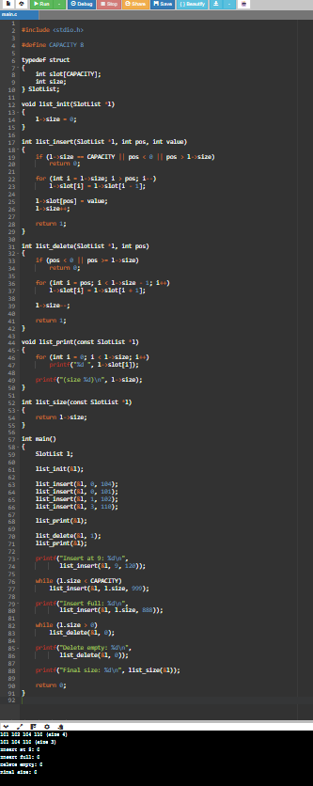
Explanation:
- Initially, four slot IDs are inserted.
- The element at position 1 is deleted.
- Insertion at invalid position 9 is rejected.
- Insertion into a full list is rejected.
- All elements are deleted.
- Deletion from an empty list is rejected.
3.10 Test Cases
Test | Operation | Expected Result
1 | Insert into empty list | Success
2 | Insert at front | Success
3 | Insert in middle | Success
4 | Insert at end | Success
5 | Delete middle element | Success
6 | Insert at invalid position | Failure
7 | Insert at negative position | Failure
8 | Insert into full list | Failure
9 | Delete from empty list | Failure
10 | Delete at position equal to size | Failure

3.11 Array vs Linked List Comparison

Feature | Array | Linked List
Memory allocation | Contiguous | Dynamic
Access | O(1) by index | O(n)
Insertion at beginning | O(n) | O(1) if head is available
Deletion at beginning | O(n) | O(1)
Memory overhead | Less | More due to pointers
Capacity | Fixed | Limited by available memory
Implementation | Simple | Comparatively complex
Decision: An array-based SlotList is selected because it is simple, provides direct access, and is suitable for a small ordered list of available parking slot IDs. A linked list is useful when the list needs to grow dynamically.

3.12 Time and Space Complexity

Operation | Time Complexity | Reason
Initialize | O(1) | Sets size to zero
Insert at end | O(1) | No shifting required
Insert at beginning | O(n) | Elements must be shifted
Delete at end | O(1) | Only decreases size
Delete at beginning | O(n) | Elements must be shifted
Print | O(n) | Visits all elements
Size | O(1) | Returns stored size
Space Complexity: O(n), because the array stores up to CAPACITY elements.
3.13 Conclusion
The SlotList ADT provides an organized way to manage available parking slot IDs. The array implementation supports initialization, insertion, deletion, printing, and size operations. It maintains the required conditions and handles invalid operations safely. The array implementation is suitable for a small list, while a linked list provides more flexibility for dynamic storage.

TASK 4 – Analyse Array Storage (4 Marks)
4.1 Introduction
An array is a linear data structure that stores elements of the same data type in contiguous memory locations. In the Smart Parking Management System, arrays are used to store parking slot numbers, slot status, and vehicle details.
Since the system contains 80,000 parking slots, proper array representation helps in accessing and managing parking information efficiently.
4.2 One-Dimensional Array
A one-dimensional array stores elements in a single row.
Example:
int slots[5] = {101, 102, 103, 104, 105};
Here, five parking slot IDs are stored in one array.
Advantages:
- Simple to implement.
- Direct access using an index.
- Requires less memory overhead.
- Access time is O(1).
4.3 Address Calculation of a One-Dimensional Array
The address of an array element is calculated using:
\[ LOC(A[i]) = BA + (i \times w) \]
Where:
- BA = Base address of the array.
- i = Index of the element.
- w = Size of each element in bytes.
Example:
Assume:
- Base address = 1000
- Each integer occupies 4 bytes.
- Required index = 3.
\[ LOC(A[3]) = 1000 + (3 \times 4) \]
\[ =1000+12 \]
\[ \boxed{1012} \]
Therefore, the address of A[3] is 1012.
4.4 Two-Dimensional Array
A two-dimensional array stores elements in rows and columns. It is suitable for representing multiple parking levels and their slots.
Example:
int parking[3][4] = {
{1, 0, 1, 0},
{0, 1, 0, 1},
{1, 1, 0, 0}
};
Here:
- Rows represent parking levels.
- Columns represent parking slots.
- 1 represents occupied.
- 0 represents free.
Address Calculation of a Two-Dimensional Array
In C, two-dimensional arrays are stored in row-major order.
\[ LOC(A[i][j])=B+(i\times C+j)\times s \]
Where:
- B = Base address
- i = Row index
- j = Column index
- C = Number of columns
- s = Size of each element
Example:
Assume:
- Base address = 2000
- Number of columns = 8
- Element size = 4 bytes
- Required element = A[3][2]
\[ =2000+(3\times8+2)\times4 \]
\[ =2000+(24+2)\times4 \]
\[ =2000+104 \]
\[ \boxed{2104} \]
Therefore, the address of A[3][2] is 2104.
Address Difference Example
Consider:
int m[3][4];
To calculate the distance between m[2][1] and m[0][0]:
\[ (2\times4)+1=9\text{ elements} \]
Since each integer occupies 4 bytes:
\[ 9\times4=36\text{ bytes} \]
Therefore, the address difference is 36 bytes.

4.5 Types of Array Storage

Type | Example | Storage | Description
Fixed Array | int a[100]; | Automatic or static storage | Size is fixed
Variable-Length Array | int a[n]; | Automatic storage | Size is decided at runtime
Dynamic Array | malloc() | Heap memory | Memory is allocated at runtime and can be resized using realloc()
1. Fixed Array
int slots[100];
- Size is decided during compilation.
- Cannot grow automatically.
- Simple to implement.
2. Variable-Length Array (VLA)
int n = 10;
int slots[n];
- Size is decided at runtime.
- Uses automatic storage.
- Very large arrays may cause stack problems.
- VLA support is optional in C11.
3. Dynamic Array
int *slots;

slots = (int *)malloc(100 * sizeof(int));
- Memory is allocated during runtime.
- Can be resized using realloc().
- Memory must be released using free().
4.6 Array and Pointer Relationship
When an array is passed to a C function, its name is treated as a pointer to its first element.
For example:
void display(int a[], int n)
is equivalent to:
void display(int *a, int n)
Only the address is passed to the function. Therefore, the array length must be passed separately. Important: Inside the function, sizeof(a) gives the size of the pointer, not the complete original array.
4.7 Predict the Output of an Array and Pointer Program
The following C program demonstrates array initialization, pointer arithmetic, passing arrays to functions, and modifying array elements.
C Program:
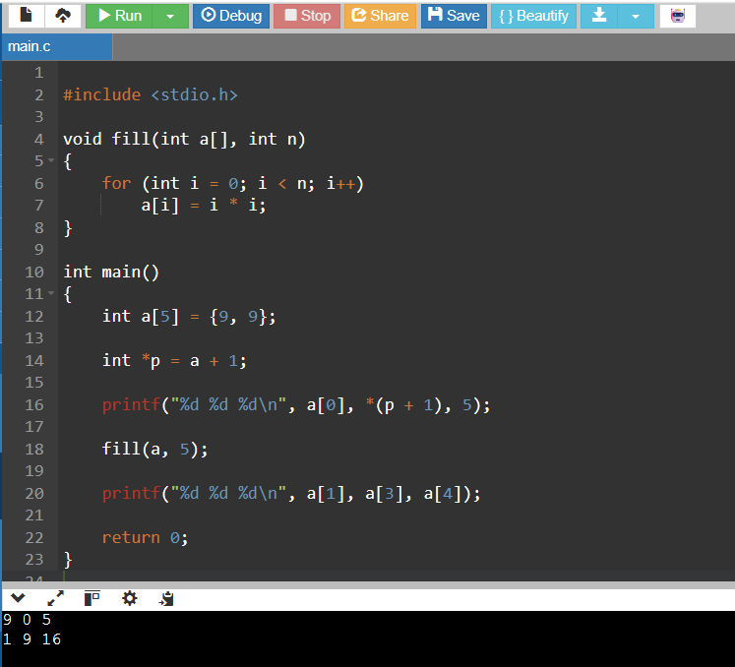

Step-by-Step Explanation
Step | Operation | Array Values | Explanation
1 | int a[5] = {9,9}; | 9, 9, 0, 0, 0 | Remaining elements are initialized to zero.
2 | int *p = a + 1; | 9, 9, 0, 0, 0 | Pointer points to a[1].
3 | First printf | 9 0 5 | a[0]=9, *(p+1)=a[2]=0.
4 | fill(a,5) | 0, 1, 4, 9, 16 | Each element becomes its index squared.
5 | Second printf | 1 9 16 | Displays a[1], a[3], and a[4].
Note: The sample answer sheet states that its original pointer/array question was not reproduced, so this is a reconstructed example matching the sample's stated output.
4.8 Insertion and Deletion in Arrays
A. Insertion
Insertion means adding a new element at a specified position.
Example:
Original array:
10, 20, 30, 40
Insert 25 at position 2.
Steps:
- Shift 40 one position to the right.
- Shift 30 one position to the right.
- Insert 25 at position 2.

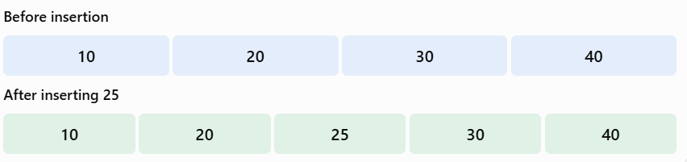
Time Complexity: O(n) for insertion in the middle or beginning, because elements must be shifted.
B. Deletion
Deletion means removing an element from a specified position.
Example:
Original array:
10, 20, 30, 40
Delete 20 from position 1.
Steps:
- Remove the element 20.
- Shift 30 one position to the left.
- Shift 40 one position to the left.
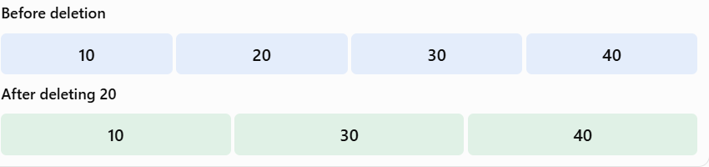

Time Complexity: O(n) for deletion from the middle or beginning, because elements must be shifted.

4.9 Dynamic Array and Doubling Strategy
A dynamic array can increase its capacity when it becomes full.
The doubling strategy means that whenever the array becomes full, its capacity is doubled.
Example:

Operation | Old Capacity | New Capacity
Initial allocation | 2 | 2
Array becomes full | 2 | 4
Array becomes full | 4 | 8
Array becomes full | 8 | 16
Array becomes full | 16 | 32

Advantages:

- Automatically increases storage capacity.
- Reduces frequent memory reallocations.
- Supports a growing parking system.
- Provides O(1) amortized insertion at the end.

A resizing operation itself takes O(n) time because existing elements must be copied to the new memory area.

4.10 Complexity Comparison

Array Operation | Time Complexity | Reason
Access by index | O(1) | Direct indexing
Traversal | O(n) | Visits every element
Insertion at beginning | O(n) | Shifting required
Insertion in middle | O(n) | Shifting required
Insertion at end | O(1) | If capacity is available
Deletion at beginning | O(n) | Shifting required
Deletion in middle | O(n) | Shifting required
Deletion at end | O(1) | No shifting required
Dynamic array resizing | O(n) | Copies existing elements

4.11 Conclusion

Arrays are important in the Smart Parking Management System because they provide direct access to parking slot information. One-dimensional and two-dimensional arrays help organize parking slots across multiple levels. Dynamic arrays support changing capacity, while insertion and deletion operations require shifting elements. Therefore, selecting the correct array representation improves memory utilization and system performance.

TASK 5 – Analyse Recursive Solutions (4 Marks)

5.1 Introduction to Recursion

Recursion is a programming technique in which a function calls itself to solve a problem.
Every recursive function contains two important parts:
- Base Case: The condition that stops the recursive calls.
- Recursive Case: The part where the function calls itself with a smaller input.

If the base case is missing, recursion may continue without stopping and cause a stack overflow.

5.2 Call Stack

The call stack is a memory structure that stores information about function calls.

- When a function is called, a stack frame is created.
- Each frame stores parameters, local variables, and the return address.
- When the function finishes, its frame is removed.
- The last function called returns first (LIFO – Last In, First Out).

5.3 Recursion vs Iteration

Recursion | Iteration
Function calls itself. | Uses loops such as for and while.
Uses stack memory. | Usually uses constant extra space.
Suitable for divide-and-conquer problems. | Suitable for repeated operations.
Function-call overhead is present. | Usually faster for simple operations.
May cause stack overflow. | May cause an infinite loop if the condition is incorrect.

5.4 Part A – Predict the Output of Recursive Functions

1. Recursive Function: show(n)

The function prints a number before calling itself and prints the same number again after the recursive call returns.

C Program:

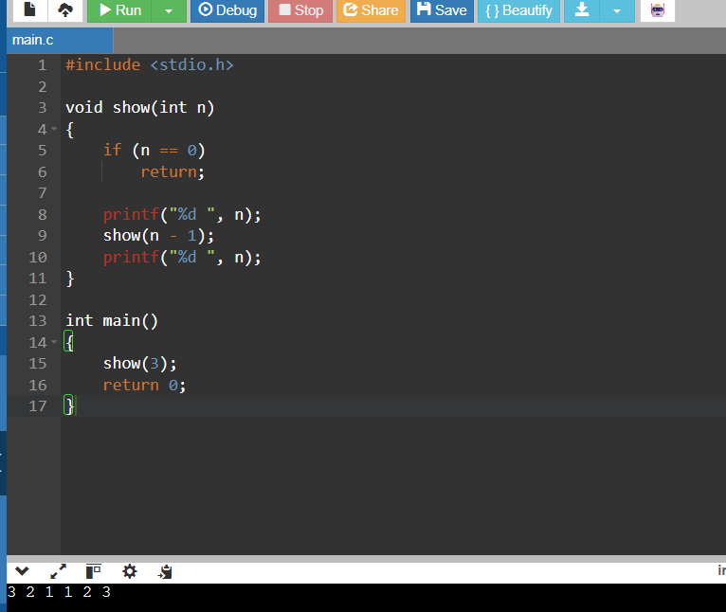

Trace of show(3)
Event | Action | Stack | Printed Output
1 | Call show(3) | show(3) | –
2 | Print 3, call show(2) | show(3), show(2) | 3
3 | Print 2, call show(1) | show(3), show(2), show(1) | 3 2
4 | Print 1, call show(0) | show(3), show(2), show(1), show(0) | 3 2 1
5 | Base case returns | Previous calls remain | 3 2 1
6 | Print 1 and return | show(3), show(2) | 3 2 1 1
7 | Print 2 and return | show(3) | 3 2 1 1 2
8 | Print 3 and return | Empty | 3 2 1 1 2 3

Number of calls:
[ n+1=3+1=boxed{4} ]

2. Recursive Function: mystery(n)

The function is defined as:
\[ mystery(n)=mystery(n/2)+(n\%2) \]

It counts the number of 1s in the binary representation of a number.

Examples:

Number | Binary Representation | Number of 1s | Result
5 | 101 | 2 | 2
8 | 1000 | 1 | 1
15 | 1111 | 4 | 4

C Program:

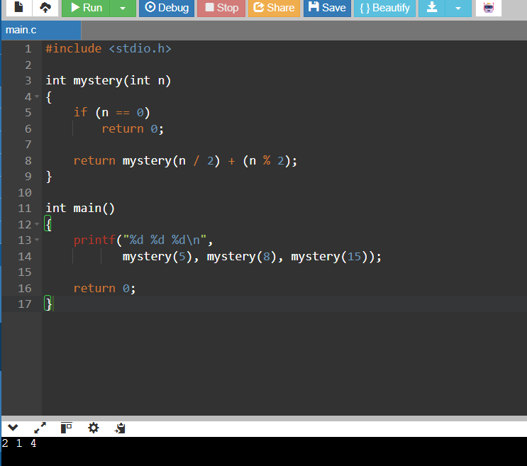

Step-by-Step Trace

Number | Recursive Calculation | Result
5 | 0 → 1 → 1 → 2 | 2
8 | 0 → 1 → 1 → 1 | 1
15 | 0 → 1 → 2 → 3 → 4 | 4

Combined Predicted Output:

3 2 1 1 2 3
2 1 4

5.5 Running Time and Space Complexity

A. Complexity of show(n)
Each function call makes one more call with n-1.
Recurrence relation:

[ T(n)=T(n-1)+c ]

After repeated expansion:
[ T(n)=cn+d ]

Therefore:
- Time Complexity = O(n)
- Space Complexity = O(n)

B. Complexity of mystery(n)
Each call divides the input by 2.
Recurrence relation:
[ T(n)=T(n/2)+c ]

The input becomes smaller until it reaches zero.
Therefore:
- Time Complexity = O(log n)
- Space Complexity = O(log n)

Comparison

Function | Recurrence | Time Complexity | Stack Space
show(n) | T(n) = T(n−1) + c | O(n) | O(n)
mystery(n) | T(n) = T(n/2) + c | O(log n) | O(log n)

5.6 Part B – Counting Free Parking Slots

In the Smart Parking Management System:
- 1 represents an occupied parking slot.
- 0 represents a free parking slot.

Consider the following status array:

int a[10] = {1,0,0,1,1,0,1,0,1,1};

The array contains four free slots at indices 1, 2, 5, and 7.

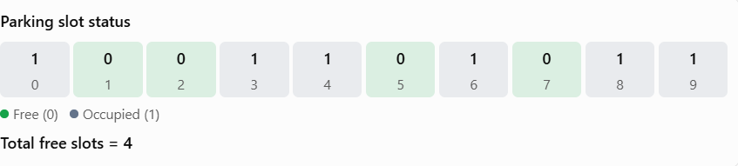
We compare three methods for counting free slots.

1. Linear Recursion
Linear recursion checks one parking slot at a time and reduces the problem size by one.
C Program:

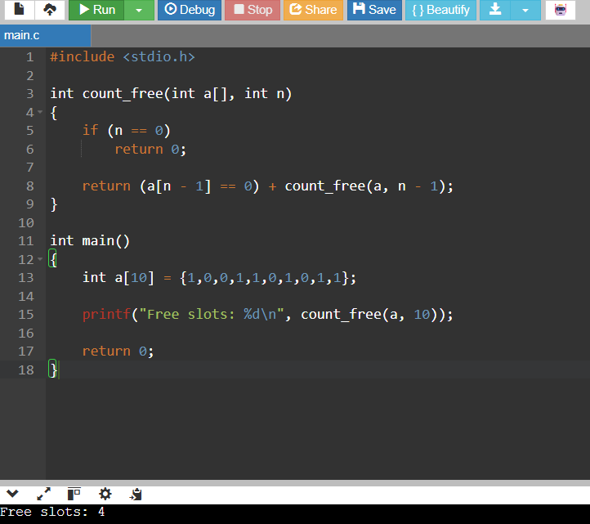

Number of function calls:
\[ n+1=10+1=\boxed{11} \]
Complexity:
- Time: O(n)
- Space: O(n)

Trace of Linear Recursion

Call | n | Element Checked | Free Slots Found
1 | 10 | a[9] = 1 | 0
2 | 9 | a[8] = 1 | 0
3 | 8 | a[7] = 0 | 1
4 | 7 | a[6] = 1 | 1
5 | 6 | a[5] = 0 | 2
6 | 5 | a[4] = 1 | 2
7 | 4 | a[3] = 1 | 2
8 | 3 | a[2] = 0 | 3
9 | 2 | a[1] = 0 | 4
10 | 1 | a[0] = 1 | 4
11 | 0 | Base case | 4

2. Split (Divide-and-Conquer) Recursion
In this method, the array is divided into two halves. Each half is checked recursively, and the results are added.

C Program:
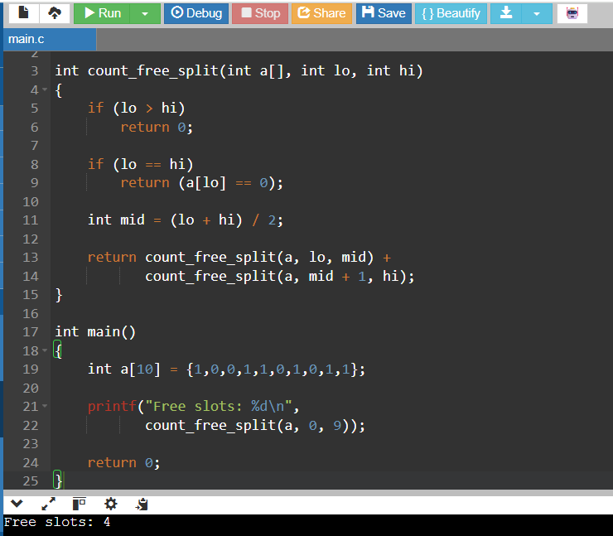

Division of Array

Level | Ranges | Number of Calls
0 | [0–9] | 1
1 | [0–4], [5–9] | 2
2 | [0–2], [3–4], [5–7], [8–9] | 4
3 | Smaller ranges | 8
4 | Single-element ranges | 4
Total |  | 19

The maximum recursion depth is approximately 5 frames for this example.

3. Iterative Method (Using Loop)

An iterative method uses a loop to check each parking slot and count the free slots.

C Program:

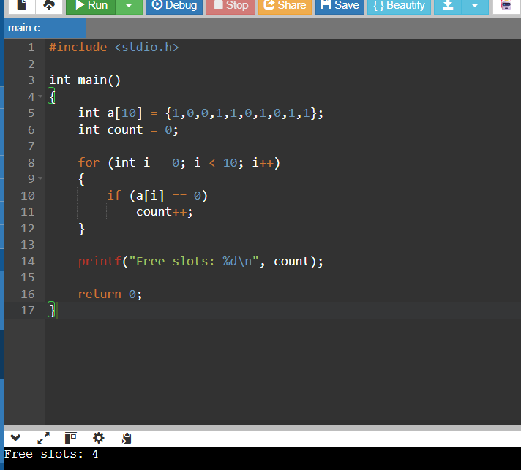

Complexity:
- Time: O(n)
- Space: O(1)

5.7 Comparison of Three Methods

Method | Calls for n = 10 | Calls for n = 80,000 | Time | Auxiliary Space
Linear Recursion | 11 | 80,001 | O(n) | O(n)
Split Recursion | 19 | 159,999 | O(n) | O(log n)
Iterative Loop | 0 recursive calls | 0 recursive calls | O(n) | O(1)

Stack Depth Comparison

Number of Slots | Linear Recursion | Split Recursion
200 | 201 | 9
2,000 | 2,001 | 12
80,000 | 80,001 | 18

The linear recursive method requires many stack frames for a large parking facility. Split recursion reduces the maximum depth, while an iterative loop does not require recursive stack frames.

5.8 Final Recommendation

For the Smart Parking Management System, the iterative loop is the best practical choice for counting free parking slots because:
- It requires O(1) auxiliary space.
- It has no recursive function-call overhead.
- It avoids recursion stack overflow.
- It is simple to implement and understand.
- It provides O(n) time complexity.

5.9 Conclusion

Recursion is useful for solving problems by reducing them into smaller problems. The show() function demonstrates linear recursion, while mystery() demonstrates divide-by-two recursion. For counting free parking slots, linear recursion, split recursion, and iteration all produce the correct result of four free slots. However, the iterative method is more suitable for managing a large parking facility containing 80,000 slots.

TASK 6 – Count the Steps of an Algorithm (4 Marks)

6.1 Introduction

Algorithm analysis helps us understand how the number of operations increases when the input size increases.
In the Smart Parking Management System, we analyse four loop patterns and calculate their operation counts for different parking-lot sizes.
For this task, we first take \(n=16\).

6.2 Analysis of Four Loop Patterns

Loop A – Nested Loop
C Code:

for (int i = 0; i < n; i++)
{
for (int j = 0; j <= i; j++)
{
count++;
}
}

Explanation:
- The outer loop runs 16 times.
- The inner loop runs 1, 2, 3, ..., 16 times.
- Total operations are the sum of these values.
[ 1+2+3+cdots+16 ]
[ =frac{n(n+1)}{2} ]
For (n=16):
[ =frac{16(17)}{2}=boxed{136} ]
Time Complexity: (Theta(n^2))

Loop B – Doubling Loop
C Code:

for (int i = 1; i < n; i = i * 2)
{
count++;
}

Explanation:
The value of i doubles in every iteration.
For (n=16):

Iteration | Value of i
1 | 1
2 | 2
3 | 4
4 | 8
Stop | 16

Number of iterations:
[ log_2 16=boxed{4} ]
Time Complexity: \(\Theta(\log n)\)

Loop C – Nested Loop with Doubling
C Code:

for (int i = 0; i < n; i++)
{
for (int j = 1; j < n; j = j * 2)
{
count++;
}
}

Explanation:
- Outer loop runs 16 times.
- Inner loop runs 4 times.
- Total operations = 16 × 4.
[ 16times4=boxed{64} ]
Time Complexity: (Theta(nlog n))

Loop D – Square Root Loop
C Code:

for (int i = 0; i * i < n; i++)
{
count++;
}

Explanation:
The loop continues until \(i^2\) becomes greater than or equal to \(n\).
For (n=16):

Iteration | Value of i | Condition
1 | 0 | 0 < 16
2 | 1 | 1 < 16
3 | 2 | 4 < 16
4 | 3 | 9 < 16
Stop | 4 | 16 is not less than 16

Number of iterations = 4.
[ lceilsqrt{16}rceil=boxed{4} ]
Time Complexity: (Theta(sqrt n))

6.3 Comparison of Four Loops

Loop | Counting Formula | Count for n = 16 | Time Complexity
A | n(n+1)2 | 136 | \(\Theta(n^2)\)
B | log_2 n | 4 | \(\Theta(\log n)\)
C | (nlog_2 n) | 64 | \(\Theta(n\log n)\)
D | \(\lceil\sqrt n\rceil\) | 4 | \(\Theta(\sqrt n)\)

6.4 C Program to Calculate the Operation Counts

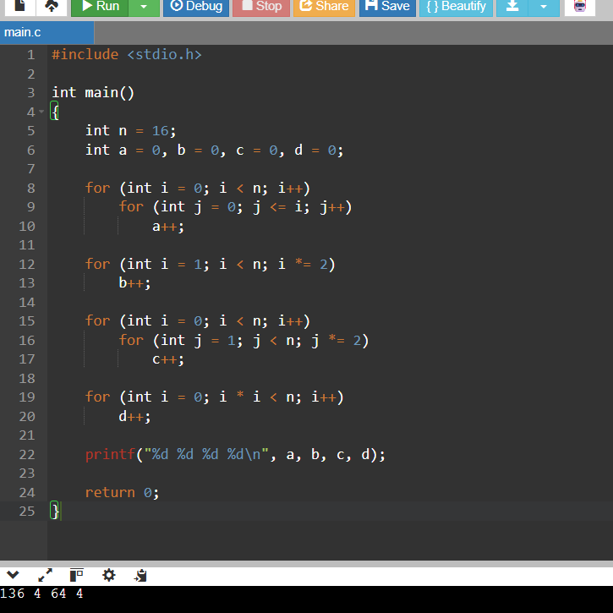

6.5 Meaning of Asymptotic Notations

Notation | Meaning
Big-O – \(O\) | Gives the upper bound of an algorithm's growth.
Big-Omega – \(\Omega\) | Gives the lower bound of an algorithm's growth.
Big-Theta – \(\Theta\) | Gives the tight bound of an algorithm's growth.

6.6 Growth Analysis for Different Parking-Lot Sizes
We calculate the growth for three parking-lot sizes: 200, 2,000, and 80,000 slots.

Number of Slots (n) | \(n^2\) | \(\log_2 n\) | \(n\log_2 n\)
200 | 40,000 | 7.64 | 1,529
2,000 | 4,000,000 | 10.97 | 21,932
80,000 | 6,400,000,000 | 16.29 | 1,303,017

Values are approximate; the table follows the teacher's sample.

Observation:
- When the number of slots increases, the number of operations also increases.
- Quadratic growth \(n^2\) increases very rapidly.
- Logarithmic growth increases slowly.
- \(n\log n\) grows more slowly than \(n^2\).

For example, increasing the parking slots from 2,000 to 80,000 multiplies \(n\) by 40, but \(n^2\) increases by 1,600 times.
Therefore, quadratic algorithms are unsuitable for large parking facilities.

6.7 Maintaining the Free-Slot Count

In the Smart Parking Management System, free slots can be counted in two ways.

Method 1 – Scanning

- Check every parking slot.
- Count the slots whose status is free.
- Time complexity: \(O(n)\).

Method 2 – Maintaining a Counter

- Maintain a variable called free_count.
- When a vehicle parks, decrease the counter by 1.
- When a vehicle leaves, increase the counter by 1.
- Displaying the free-slot count takes \(O(1)\) time.

Operation | Scanning Method | Maintained Counter
Count free slots | O(n) | O(1)
Park a vehicle | O(1) plus scanning when recounting | O(1) update
Release a vehicle | O(1) plus scanning when recounting | O(1) update
Extra space | O(1) | O(1) per counter

If each parking level maintains its own free-slot counter, the additional space is \(O(\text{number of levels})\).

6.8 Conclusion

The analysis of four loop patterns helps us understand the growth of algorithms. Among them, the quadratic loop has the highest growth, while the logarithmic loop has the slowest growth. For the Smart Parking Management System with 80,000 slots, maintaining a free-slot counter is more efficient than scanning all slots every time. It reduces the time required to display available parking spaces from \(O(n)\) to \(O(1)\).

TASK 7 – Analyse Best, Average and Worst Cases (4 Marks)

7.1 Introduction

In the Smart Parking Management System, a guard may need to search for a vehicle using the last four digits of its parking ticket.
The number of comparisons depends on where the ticket code is located. Therefore, we analyse three cases:
- Best case: The required code is found at the first position.
- Average case: The code is found somewhere in the middle.
- Worst case: The code is at the last position or is not present.

The basic operation counted in this task is the number of key comparisons.
Data_Structures_Assignment 1 (Jul-Sep) (F).docx.pdf

7.2 Parking Ticket Data

Consider an array containing eight ticket codes in no particular order:
4521, 1180, 9034, 7765, 2290, 6612, 3478, 5501

We perform three searches:
- Search for 4521 – best case.
- Search for 2290 – middle-position example.
- Search for 1111 – absent, worst case.

7.3 Linear Search – Comparison Table

Linear search checks each element one by one until the key is found or the array ends.

Search Key | Case | Elements Compared | Comparisons | Result
4521 | Best | 4521 | 1 | Index 0
2290 | Middle | 4521, 1180, 9034, 7765, 2290 | 5 | Index 4
1111 | Worst (absent) | All 8 elements | 8 | Not found

7.4 Complexity Derivation of Linear Search

Best case:

The key is at the first position.
\[ C_{\text{best}}=1 \]
Time complexity: \(\Theta(1)\)

Worst case:

The key is at the last position or is absent.
\[ C_{\text{worst}}=n \]
For \(n=8\), comparisons = 8.
Time complexity: \(\Theta(n)\)

Average case (successful search):

Assumption: The key is present and every position is equally likely.
\[ C_{\text{avg}}=\frac{1+2+3+\cdots+n}{n} \]
Using the sum formula:
\[ C_{\text{avg}}=\frac{n(n+1)}{2n} \]
\[ \boxed{C_{\text{avg}}=\frac{n+1}{2}} \]
For \(n=8\):
\[ C_{\text{avg}}=\frac{8+1}{2}=\boxed{4.5} \]

Therefore, average-case time complexity is \(\Theta(n)\).

7.5 Average Case When Searches Can Be Unsuccessful

Let \(q\) be the probability that the searched ticket code is present.
\[ E=q\times\frac{n+1}{2}+(1-q)\times n \]

For example, when \(n=8\) and \(q=0.5\):
\[ E=0.5(4.5)+0.5(8) \]
\[ =2.25+4=\boxed{6.25} \]

7.6 C Program for Linear Search and Binary Search

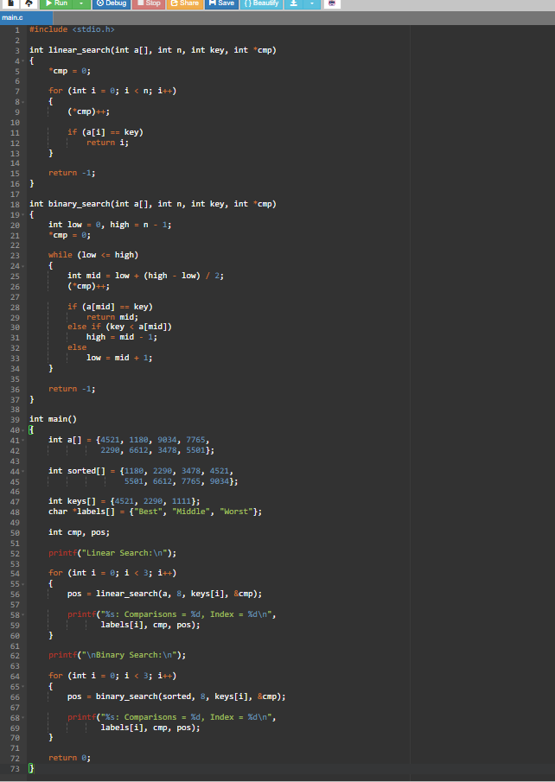

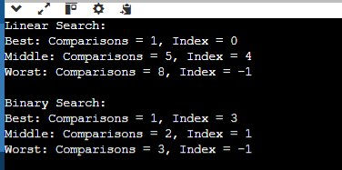

7.7 Binary Search

Binary search requires the array to be sorted. It compares the key with the middle element and repeatedly searches either the left half or right half.

Sorted ticket codes:
1180, 2290, 3478, 4521, 5501, 6612, 7765, 9034

Example: Search for 2290

Step | Low | High | Middle | Middle Value | Decision
1 | 0 | 7 | 3 | 4521 | Search left
2 | 0 | 2 | 1 | 2290 | Found
Total comparisons = 2.
Binary Search Complexity:

Each comparison removes approximately half of the remaining elements.
\[ \boxed{C_{\text{worst}}=\lfloor\log_2 n\rfloor+1} \]
Time complexity: \(\Theta(\log n)\).

7.8 Linear Search vs Binary Search

Number of Slots | Linear Worst | Linear Average | Binary Worst
8 | 8 | 4.5 | 4
200 | 200 | 100.5 | 8
2,000 | 2,000 | 1,000.5 | 11
80,000 | 80,000 | 40,000.5 | 17

For 80,000 slots, binary search needs at most 17 comparisons, whereas linear search may need 80,000 comparisons.

7.9 Cost of Keeping Data Sorted

Binary search is faster, but it requires sorted data. When a vehicle parks or leaves, maintaining the sorted order may require shifting elements.
Operation | Unsorted Array + Linear Search | Sorted Array + Binary Search
Search | O(n) | O(log n)
Insert | O(1) by appending | O(n)
Delete | O(n) to find, then O(1) swap with last | O(n)
Sorting preparation | Not required | O(n log n)
7.10 Comparison with Hashing

Data Structure | Best Search | Average Search | Worst Search | Requires Sorted Data?
Unsorted array | O(1) | O(n) | O(n) | No
Sorted array | O(1) | O(log n) | O(log n) | Yes
Hash table (chaining) | O(1) | O(1), under suitable load factor | O(n) | No

7.11 Conclusion

Linear search is simple and works with unsorted data, but it requires more comparisons for large parking facilities. Binary search is faster, but it requires sorted data, and maintaining sorted order during parking and leaving operations takes O(n) time.

For a Smart Parking Management System with 80,000 slots and frequent updates, a hash table is a better choice for vehicle-ticket lookup because it provides O(1) average search, insertion and deletion time.

TASK 8 – Analyse Space Complexity (3 Marks)

8.1 Introduction

Space complexity measures the amount of memory required by an algorithm or data structure during execution. In the Smart Parking Management System, we need to store the status of 80,000 parking slots. This task compares an integer array with a bitmap and analyses the extra memory used by recursive and iterative counting methods.

8.2 Memory Required for an Integer Array

An integer array stores the status of each parking slot using one integer.

Formula:
\[ \text{Memory}=n\times sizeof(int) \]

Given:
- Number of slots = 80,000
- Size of one integer = 4 bytes (to be confirmed using the compiler)
\[ =80,000\times4 \]
\[ =\boxed{320,000\text{ bytes}} \]

In KiB:

\[ 320,000/1024=\boxed{312.5\text{ KiB}} \]
Therefore, an integer array requires approximately 312.5 KiB.

8.3 Memory Required for a Bitmap

A bitmap stores each parking slot's status using only one bit.
- 0 represents a free slot.
- 1 represents an occupied slot.
Formula:
\[ \text{Memory}=\frac{\text{Number of slots}}{8} \]
\[ =\frac{80,000}{8} \]
\[ =\boxed{10,000\text{ bytes}} \]

In KiB:
\[ 10,000/1024\approx9.77\text{ KiB} \]

Comparison:
\[ \frac{320,000}{10,000}=\boxed{32} \]
A bitmap uses 32 times less memory than an integer array.

8.4 Integer Array vs Bitmap

Feature | Integer Array | Bitmap
Storage per slot | 4 bytes (if int is 4 bytes) | 1 bit
Memory for 80,000 slots | 320,000 bytes | 10,000 bytes
Test one slot | O(1) | O(1)
Update one slot | O(1) | O(1)
Count free slots by scanning | O(n) | O(n)
Memory usage | Higher | Lower

8.5 C Program to Verify Memory Using sizeof and Bitmap

The following program checks the actual integer size on the computer and demonstrates how a bitmap stores slot status.

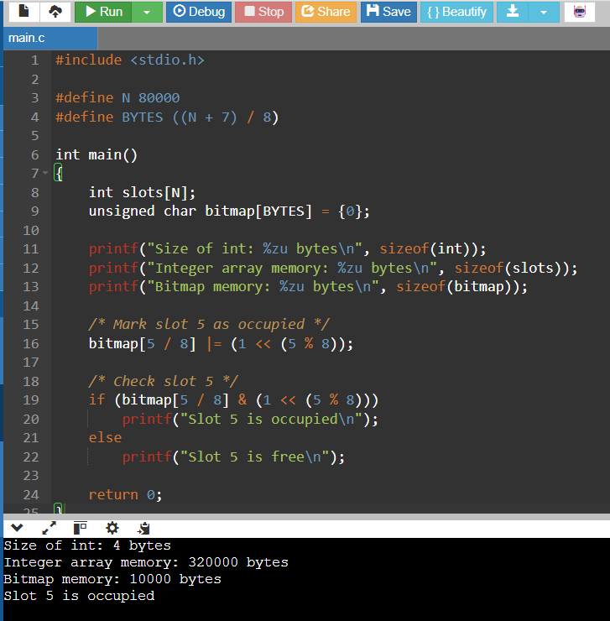

Explanation:
- sizeof(int) checks the size of an integer.
- slots[N] stores the status of 80,000 slots.
- bitmap[BYTES] allocates enough bytes to store 80,000 bits.
- The bitwise OR operation sets a slot's bit to 1.
- The bitwise AND operation checks whether the slot is occupied.
The exact integer-array size depends on the target compiler, so the sizeof result should be recorded from the computer used for testing.

8.6 Space Complexity of Recursive Counting Methods
In Task 5, we studied three methods for counting free parking slots.

Method | Time Complexity | Auxiliary Space | Reason
Linear recursion | O(n) | O(n) | Uses n + 1 stack frames
Split recursion | O(n) | O(log n) | Divides the problem into smaller halves
Simple loop | O(n) | O(1) | Uses only a few variables

Linear Recursion
- Each recursive call processes one slot.
- For 80,000 slots, it requires approximately 80,001 stack frames.
- Therefore, auxiliary space is O(n).

Split Recursion
- The problem is divided into two smaller parts.
- Maximum recursion depth is approximately 17–18 frames for 80,000 slots.
- Therefore, auxiliary space is O(log n).

Iterative Method
- Uses a simple loop to check each slot.
- Does not create recursive function calls.
- Requires only a few variables.
Therefore, auxiliary space is O(1).

8.7 Comparison of Stack Space

Method | Maximum Stack Usage for 80,000 Slots | Space Complexity
Linear recursion | 80,001 frames | O(n)
Split recursion | About 17–18 frames | O(log n)
Iterative loop | Constant space | O(1)

Important observation: If one recursive stack frame uses approximately 32 bytes, linear recursion may require around 2.5 MB of stack memory. This is an estimate; actual frame size depends on the compiler and program.

8.8 Python Program for Memory Comparison
The assignment's evaluation checklist also mentions including a Python implementation and cross-checking it with C. The following Python program provides an additional memory comparison.

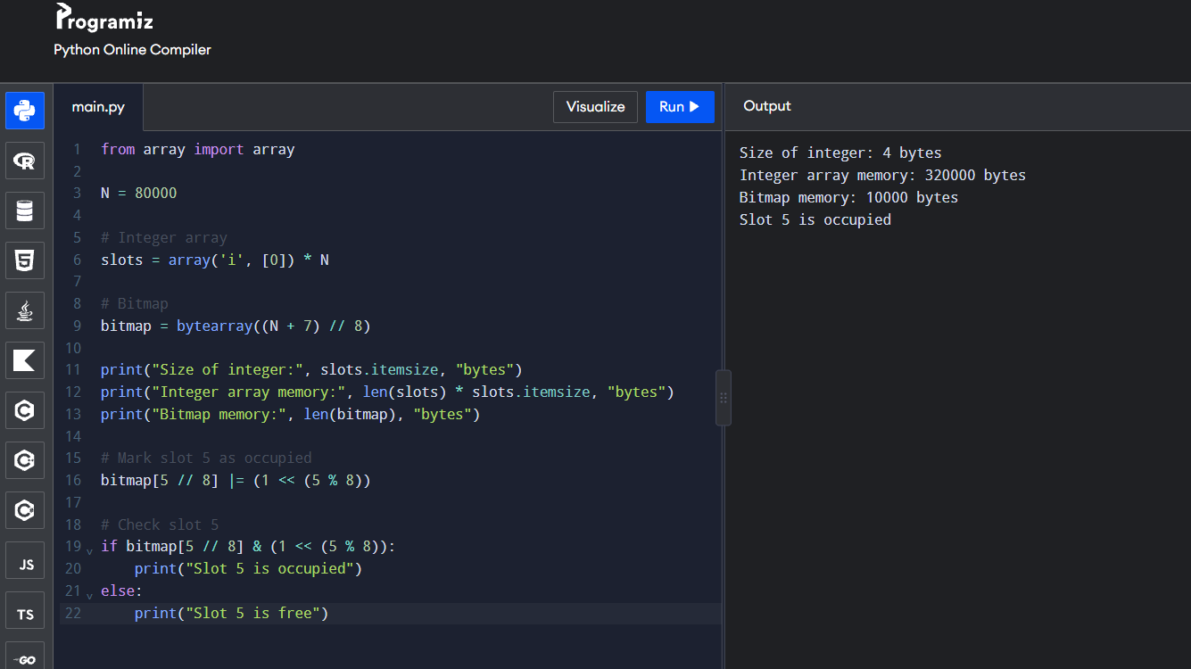

8.9 Final Summary

Representation / Method | Memory or Auxiliary Space
Integer array (80,000 slots) | 320,000 bytes
Bitmap (80,000 slots) | 10,000 bytes
Linear recursion | O(n)
Split recursion | O(log n)
Iterative loop | O(1)

8.10 Conclusion

Space complexity helps us understand how much memory is required by different data structures and algorithms. A bitmap requires only 10,000 bytes for 80,000 parking slots, whereas an integer array requires 320,000 bytes, assuming 4-byte integers. Therefore, a bitmap is memory-efficient for storing simple slot status, and an iterative method is preferable for counting free slots when memory usage is important.
TASK 9 – Implement and Test the Parking Data Structures (6 Marks)

9.1 Introduction

The aim of this task is to implement an array-based Smart Parking Management System for one parking level containing 20 slots.
The system must support the following operations:
- Initialize the parking slots.
- Park a vehicle in a free slot.
- Release a vehicle when it leaves.
- Search for a vehicle using its registration number.
- Maintain the number of free slots.
- Test normal operations and boundary conditions.
The program uses arrays to store slot status and vehicle registration numbers.

9.2 Requirements

Requirement | Description
R1 | Store slot status and vehicle registration number.
R2 | Park a vehicle and return its slot number. Return -1 if full.
R3 | Release an occupied slot and reject invalid or already-free slots.
R4 | Search for a vehicle and return its slot number. Return -1 if absent.
R5 | Maintain the free-slot count correctly.
R6 | Test empty, full, first-slot, last-slot and ten-event cases.

9.3 Data Structure Design
We use a structure named Parking.

Variable | Purpose
occupied[20] | Stores whether each slot is occupied or free.
vehicle[20][16] | Stores the vehicle registration number.
free_count | Stores the total number of free slots.
Slot status:
- 0 – Free slot
- 1 – Occupied slot
Memory calculation:
Assuming an integer uses 4 bytes:
\[ 20(4)+20(16)+4 \]
\[ =80+320+4=\boxed{404\text{ bytes}} \]

9.4 Important Conditions (Invariants)

- free_count must equal the number of free slots.
- Free count must always remain between 0 and 20.
- A free slot must have an empty vehicle registration.
- A vehicle must not be assigned to an already occupied slot.

9.5 C Program Implementation
The following program implements init, park, leave_slot, lookup, and free-slot counting.

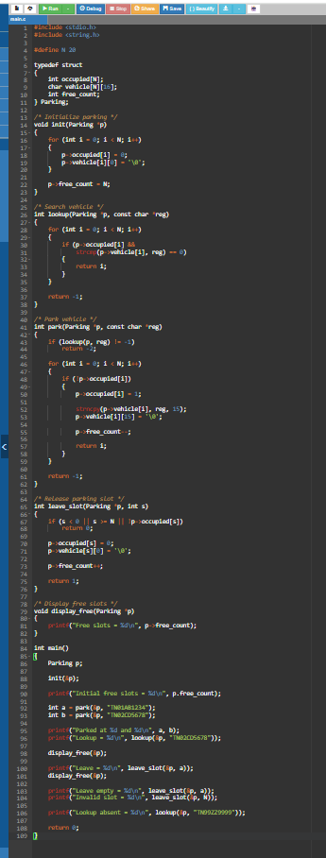
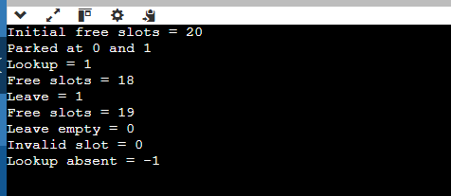

9.7 Test Cases

The following tests check whether the parking system works correctly.

Test | Operation | Expected Result
T1 | Initialize empty parking lot | Free count = 20
T2 | Search in empty lot | -1
T3 | Release an empty slot | 0
T4 | Fill all 20 slots | Free count = 0
T5 | Park when full | -1
T6 | Search for vehicle in first slot | 0
T7 | Search for vehicle in last slot | 19
T8 | Release last slot | 1; free count = 1
T9 | Park after releasing last slot | Reuses slot 19
T10 | Release slot number -1 | 0

9.8 Ten-Event Sequence
The sample uses the following sequence to check slot allocation, release, and reuse.

Event | Operation | Slot Result
1 | Park vehicle V1 | 0
2 | Park vehicle V2 | 1
3 | Park vehicle V3 | 2
4 | Release vehicle V2 from slot 1 | 1
5 | Park vehicle V4 | 1
6 | Release vehicle V1 from slot 0 | 0
7 | Park vehicle V5 | 0
8 | Search for V2 | -1
9 | Search for V4 | 1
10 | Check free-slot count | 17

This sequence follows the slot assignments and final counter result in the teacher's sample. The event table is a test illustration; run the corresponding operations in the program to capture your own console output.

9.9 Counter Consistency
The free-slot count must always match the number of unoccupied slots.
\[ \text{free\_count} = N-\text{occupied slots} \]
After the ten-event sequence:
- Total slots = 20
- Occupied slots = 3
- Free slots = 20 - 3 = 17
Therefore:
\[ \boxed{\text{free\_count}=17} \]
The counter is updated only after a successful parking or release operation.

9.10 Time and Space Complexity

Operation | Best Case | Average Case | Worst Case | Explanation
init() | Θ(N) | Θ(N) | Θ(N) | Initializes all slots.
park() | O(1) | O(N) | O(N) | Searches for a free slot; also checks for duplicate registration.
leave_slot() | O(1) | O(1) | O(1) | Direct access using slot index.
lookup() | O(1) | O(N) | O(N) | Searches vehicle registrations one by one.
Free count | O(1) | O(1) | O(1) | Reads the maintained counter.
Space complexity:
\[ N\times(4+16)+4 \]
\[ =20N+4 \]
Therefore, space complexity is:
\[ \boxed{O(N)} \]
For 80,000 slots, this simple representation requires approximately 1,600,004 bytes, assuming 4-byte integers and 16-byte vehicle fields.

9.11 Possible Improvements

The current implementation is suitable for demonstrating the basic operations for 20 slots. For a larger parking facility, we can improve it using:
- Free-slot stack: Provides O(1) allocation and release of available slot numbers.
- Hash table: Provides O(1) average vehicle lookup.
- Duplicate checking: Prevents the same vehicle from occupying two slots.
- Maintained free count: Displays available slots in O(1) time.
The teacher's sample also describes an improved version using a free-slot stack and duplicate-registration checking.

9.12 Conclusion

The Smart Parking Management System was implemented using arrays and structures. The program supports initialization, vehicle parking, vehicle release, vehicle lookup, and free-slot counting. Boundary tests and the ten-event sequence help verify the correctness of the system. The maintained free-slot counter provides O(1) access to the number of available spaces. For a larger facility containing 80,000 slots, a hash table and free-slot stack can improve performance.

TASK 10 – Compare Theory with Measurement (4 Marks)

10.1 Aim
To measure the running time of operations on arrays containing 200, 2,000, 80,000 and 1,000,000 elements and compare the measured results with theoretical time complexity.

10.2 Methodology

The following procedure is used:
- Use the same C compiler and compiler flags for all test sizes.
- Test arrays of 200, 2,000, 80,000 and 1,000,000 elements.
- Repeat scanning and lookup 100 times.
- Repeat insertion and deletion 20 times.
- Use the clock() function to measure CPU time.
- Compare the measured time with theoretical complexity.

Compiler command:

gcc -std=c11 -Wall -Wextra -pedantic t10.c -o t10

The sample uses no optimization so that all tests use the same compiler settings.

10.3 Operations Tested

Operation | Description | Theoretical Complexity
Scan | Visit every array element | Θ(n)
Lookup | Search for an element | Θ(n)
Insert at index 0 | Shift elements right | Θ(n)
Delete at index 0 | Shift elements left | Θ(n)

10.4 C Program
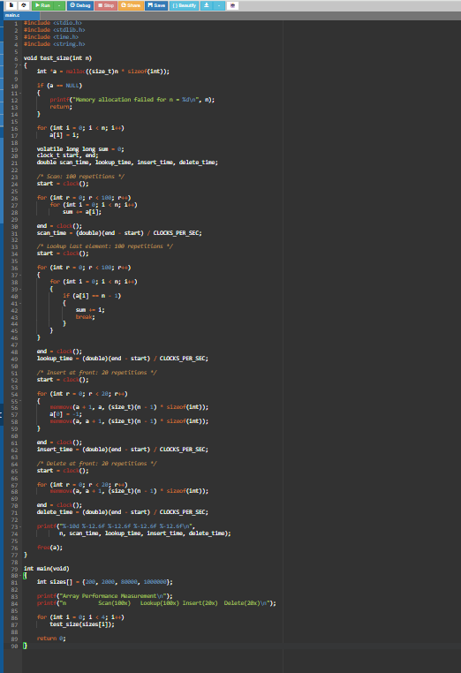

10.5 How to Run the Program
Save the file as t10.c.
For Windows using GCC:
gcc -std=c11 -Wall -Wextra -pedantic t10.c -o t10
Run:
t10
The program prints the measured time in seconds for each operation and each array size.
10.6 Sample Measured Results
The teacher's sample report gives the following results from one test environment (GCC 13.3, Linux, without optimization). These are reference results, not measurements from your laptop.
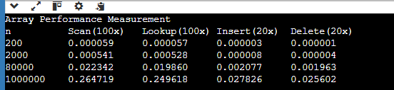

The sample table does not provide a complete row for 1,000,000 elements. Use the output from your own run for that size.

10.7 Comparison Between Theory and Measurement
For a linear operation, the expected time increases approximately in proportion to the input size.

Input size change | Theoretical growth for Θ(n) | Sample scan growth
200 → 2,000 | 10× | Approximately 6.9×
2,000 → 80,000 | 40× | Approximately 41.2×

The measured results are close to theoretical growth for larger inputs. Small-input measurements can vary because of timer resolution and computer overhead.

10.8 Operation Counting vs clock()

Operation counting | clock() measurement
Counts basic operations. | Measures CPU execution time.
Independent of computer speed. | Depends on CPU and computer conditions.
Gives reproducible theoretical results. | Gives practical timing results.
Does not consider cache effects. | Includes effects such as cache and compiler behaviour.

10.9 Conclusion

The experiment compares theoretical time complexity with measured execution time. Scanning, lookup, insertion at the beginning, and deletion at the beginning all have Θ(n) complexity because they may process or move many elements.
The experiment shows that measured running time generally increases with input size, supporting the theoretical analysis. However, actual timings depend on the computer and compiler settings.

TASK 11 – Recommend and Defend the Final Design (5 Marks)

11.1 Aim

To recommend a suitable data structure design for the Smart Parking Management System containing 80,000 parking slots, compare different design alternatives, and justify the final design using time complexity, memory requirements, and performance evidence.

11.2 Design Alternatives
Three main designs are considered.

Design | Data Structure | Advantages | Disadvantages
Design A | Simple array | Easy to implement; direct slot access | Searching and counting free slots require O(n).
Design B | Sorted array | Supports binary search in O(log n) | Insertion and deletion require shifting elements, O(n).
Design C | Arrays + Hash Table + Min-Heap + Counters | Fast lookup, slot updates, nearest-slot access and free-slot display | Requires additional memory and careful synchronization.

11.3 Recommended Design – Design C

Recommended
For 80,000 parking slots, Design C is recommended because it combines different data structures to handle different operations efficiently.

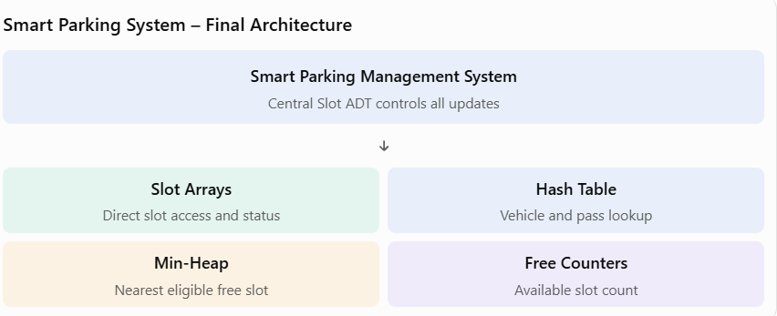

11.4 Components and Their Functions

Component | Purpose | Time Complexity
Slot array | Stores slot number, status, type and vehicle index | O(1) direct access
Hash table | Finds a vehicle using its registration number | O(1) average, O(n) worst
Min-heap | Finds the nearest free slot | O(1) to view minimum; O(log n) to insert or remove
Free counter | Stores the available slots in each level | O(1)
Slot ADT | Controls parking and release updates | Coordinates all structures

Why use these structures?
- Slot arrays provide direct access to parking information.
- Hash tables reduce the time required to find vehicles.
- Min-heaps help identify the nearest available parking slot.
- Free counters display available spaces without scanning all slots.
- A common Slot ADT ensures all structures are updated together.

11.5 Hash Table Size Calculation

The number of vehicles is assumed to be 80,000.
The hash table uses a load factor of 0.75.
\[ \alpha=\frac{\text{Number of entries}}{\text{Number of buckets}} \]
\[ 0.75=\frac{80,000}{B} \]
\[ B=\frac{80,000}{0.75}=106,666.67 \]
Therefore, approximately 106,667 buckets are required. The sample design selects the convenient prime bucket count 106,669.
A suitable load factor helps reduce collisions and maintain efficient average lookup performance.

11.6 Memory Estimation
The sample design estimates memory as follows:

Component | Calculation | Memory
Slot records | 80,000 × 16 bytes | 1,280,000 bytes
Hash nodes | 80,000 × 32 bytes | 2,560,000 bytes
Hash bucket array | 106,669 × 8 bytes | 853,352 bytes
Heap index | 80,000 × 8 bytes | 640,000 bytes
Free counters | A few integers per level | Negligible
Total |  | 5,333,352 bytes

11.7 Comparison of Operation Complexities

Operation | Simple Array | Recommended Design C
Park vehicle | O(n) | O(log n) heap operation + O(1) average hash insertion
Release vehicle | O(1) by slot; O(n) to find by registration | O(1) average hash lookup + O(log n) heap insertion
Vehicle lookup | O(n) | O(1) average
Free-slot count | O(n) if scanned | O(1)
Nearest free slot | O(n) | O(1) to view heap minimum
Slot information | O(1) | O(1)
The recommended design improves frequently used operations by using suitable indexes.

11.8 Peak-Hour Workload Comparison

The sample assumes the following activities during one peak hour:
- 600 vehicle arrivals.
- 600 vehicle departures.
- 1,500 vehicle-location lookups.
- 3,600 free-slot display refreshes.

Activity | Number of operations | Design A: Simple Array | Design C: Recommended
Park | 600 | 48,000,000 | 21,840
Leave | 600 | 24,000,300 | 11,040
Lookup | 1,500 | 60,000,750 | 2,100
Display refresh | 3,600 | 288,000,000 | 3,600
Total |  | 420,001,050 | 38,580

These are estimated basic-operation counts based on the sample workload, not measured execution times.
The comparison shows that Design C requires far fewer basic operations than the simple array design under these assumptions.

11.9 Why Other Designs Are Rejected

Design | Reason for Rejection
Simple array | Searching and free-slot counting take O(n), which is costly for 80,000 slots.
Sorted array | Parking and releasing vehicles may require shifting many elements.
Balanced tree | Provides O(log n) lookup, but is more complex and does not independently solve nearest-slot queries.
Linked list | Searching takes O(n), and direct slot access is unavailable.

11.10 Risks and Solutions

Risk | Solution
Hash collisions | Use a good hash function and maintain load factor at or below 0.75.
Rehashing delay | Allocate sufficient buckets initially.
Memory allocation failure | Check memory allocation before using it.
Inconsistent structures | Update arrays, hash table, heap and counters through one Slot ADT.
Incorrect nearest-slot result | Update the heap whenever a slot is occupied or released.
Data_Structures_Assignment 1 (Jul-Sep) (F).docx.pdf

11.11 Evidence Supporting the Final Design
The sample report provides the following evidence:

Claim | Supporting Evidence
Hash lookup is efficient | 1.397 average comparisons versus 40,000.5 for linear search.
Slot access is O(1) | Direct array indexing.
Free count is O(1) | Maintained counter and consistency tests.
Heap finds nearest slot efficiently | Heap operation counts and zero mismatches against the scanning method.
Overall latency is improved | Still needs measurement on the submission computer.

11.12 Final Recommendation

For a parking facility containing 80,000 slots, Design C is the most suitable choice.
It combines:
- Arrays for direct slot access.
- Hash tables for fast vehicle and pass lookup.
- Min-heaps for nearest free-slot selection.
- Maintained counters for available-space information.
- A common Slot ADT to maintain consistency.

Although Design C requires more memory and implementation effort, its improved operation costs make it suitable for a large parking facility. For a small prototype with around 200 slots, a simple array may still be sufficient.

11.13 Conclusion

The final design uses multiple data structures to improve the efficiency of the Smart Parking Management System. Compared with a simple array, It supports fast vehicle lookup, direct slot access, nearest-slot selection and free-space counting. Therefore, Design C is recommended for the 80,000-slot parking facility. Actual execution-time improvements must still be verified through measurements on the target computer.
TASK 12 – Re-evaluate and Adapt the Design (4 Marks)

12.1 Aim

To evaluate the existing Smart Parking Management System when three new requirements are introduced:
- Electric Vehicle (EV) reservations.
- Nearest parking slot display.
- Monthly parking passes.

The aim is to identify the changes required in the data structures, implement a revised nearest-free-slot function, and justify the adapted design.

  - Part A – Impact Analysis

A.New data requirements

New Requirement | New Data Required | Purpose
EV reservations | EV-reserved flag and vehicle type | Identify slots reserved for electric vehicles.
Nearest-slot display | Distance of each slot from the lift | Find the closest available slot.
Monthly passes | Pass ID, vehicle registration, valid-from date and valid-to date | Verify whether a vehicle has a valid pass.

B. New and changed operations

Operation | Changes Required
Park | Check vehicle eligibility and pass validity before allocating a slot.
Leave | Return the released slot to the correct availability index.
Nearest-free-slot query | Find the closest available eligible slot.
Pass validation | Check pass ID or vehicle registration and validity dates.
EV reservation | Reserve or release EV-specific parking spaces.

Important: Validation must happen before allocation. If a vehicle is not eligible, the system should reject it without changing the parking records.

  - Part B – Evaluate the Original Design

The original design uses a simple array.
To find the nearest free slot, the program must:
- Check each parking slot.
- Skip occupied slots.
- Skip EV-reserved slots for ordinary vehicles.
- Compare the distances of eligible free slots.
- Return the slot with the smallest distance.
This requires O(n) time for each nearest-slot query.

Number of Slots | Checks per Query | Checks for 1,000 Queries
200 | 200 | 200,000
2,000 | 2,000 | 2,000,000
80,000 | 80,000 | 80,000,000

Conclusion: The original array design works correctly, but repeated scanning becomes expensive for a large parking facility. It is suitable for a prototype, while a distance-based index is better for production.

12.4 Part C – Implement the Revised Nearest-Free-Slot Function

A. C Program

The following program stores three details for every slot:
- occupied – whether the slot is occupied.
- ev_reserved – whether the slot is reserved for EVs.
- distance – distance from the lift.

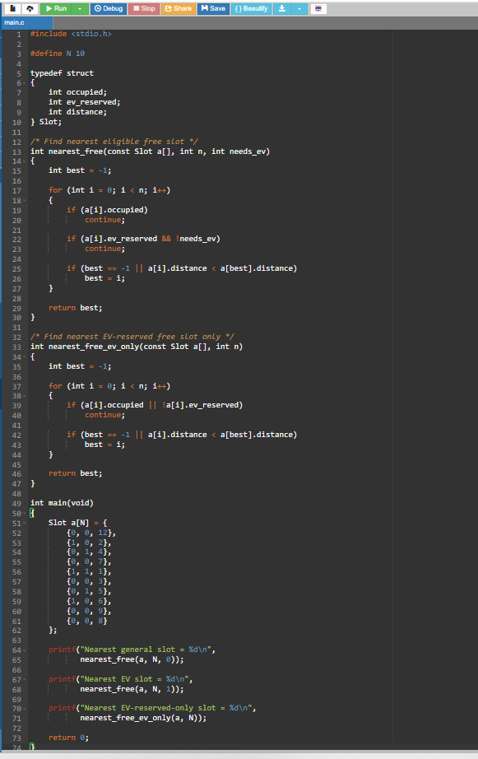

B. Explanation of the Program

Statement | Explanation
int best = -1; | Initially, no free slot is selected.
if (a[i].occupied) | Skips occupied slots.
if (a[i].ev_reserved && !needs_ev) | Prevents ordinary vehicles from using EV-reserved slots.
Distance comparison | Selects the slot closest to the lift.
return best; | Returns the selected slot number or -1 if none is available.

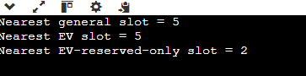

Explanation:
- Slot 5 is the nearest eligible free slot for a general vehicle. Its distance is 3.
- Slot 5 is also available to an EV under the sample's rule that EVs may use general slots.
- Slot 2 is the nearest free EV-reserved slot, with distance 4.
If the system requires EVs to use EV-reserved slots whenever possible, it can try the EV-only function first and use the general function as a fallback.

D. Test Cases

Test | Situation | Expected Result
1 | Sample data, general vehicle | Slot 5
2 | Sample data, EV vehicle | Slot 5
3 | All slots occupied | -1
4 | Only EV-reserved slots free; general vehicle | -1
5 | Only EV-reserved slots free; EV vehicle | Nearest EV-reserved slot
6 | Two free slots have equal distance | Lower slot index
7 | Only one slot exists and it is free | Slot 0
8 | No slots (n = 0) | -1

E. Complexity Analysis

Operation | Time Complexity | Reason
Nearest free slot | O(n) | Checks all slots.
EV eligibility check | O(1) per slot | Checks the reservation flag.
Distance comparison | O(1) per slot | Compares two distances.
Extra space | O(1) | Uses only a few variables.

Therefore, the revised scanning function has O(n) time and O(1) extra space.

12.5 Part D – Adapted Design Using a Min-Heap

To improve performance, the system can use a Binary Min-Heap ordered by distance from the lift.
A min-heap stores the smallest distance at its root.

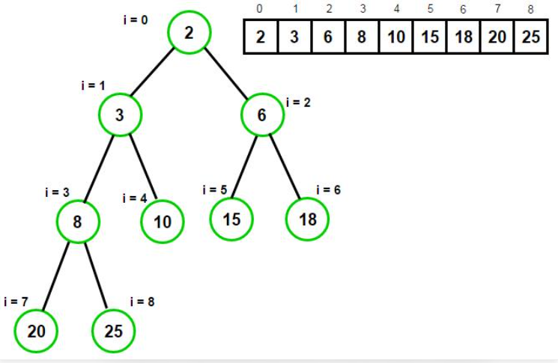

How it works
- Store available slots in a min-heap according to distance.
- The root contains the nearest free slot.
- When a vehicle parks, remove that slot from the heap.
- When a vehicle leaves, insert the released slot back into the heap.
- Maintain separate general and EV-reserved heaps if required.

Complexity comparison

Operation | Original Array Scan | Min-Heap
View nearest free slot | O(n) | O(1)
Allocate nearest slot | O(n) | O(log n)
Release a slot | O(1) by index | O(log n)
Extra memory | No additional index | O(n)

For 80,000 slots, the heap index requires approximately:

\[ 80,000\times8=640,000\text{ bytes} \]

The slot array should still be maintained because a heap cannot efficiently find the status of an arbitrary slot number.

12.6 Experimental Comparison: Scan vs Heap

The sample experiment compares both methods using the same queries for different parking sizes.
Slots | Queries | Array Scan Checks | Heap Comparisons | Mismatches
200 | 100 | 20,000 | 1,476 | 0
2,000 | 1,000 | 2,000,000 | 22,184 | 0
80,000 | 40,000 | 3,200,000,000 | 1,394,226 | 0

These are the operation-count results reported in the sample, not execution-time measurements.
Interpretation:
- Both methods returned slots with the same minimum distance in all 41,100 queries.
- The heap required significantly fewer comparisons.
- The heap's work grows approximately logarithmically rather than linearly.
- Actual speed improvement must still be verified using execution-time measurements on the target computer.

12.7 Complete Adapted Design

Feature | Original Design | Adapted Design
Slot storage | Array | Array
Vehicle lookup | Linear search | Hash table
EV reservations | Not supported | EV-reserved flag and separate index
Nearest slot | Linear scan | Min-heap
Monthly passes | Not supported | Pass records and hash lookup
Free-slot count | Maintained counter | Maintained counter

12.8 Final Recommendation

The original array design should be retained for basic slot storage but improved with additional data structures.

The final adapted design should contain:
- Arrays for storing parking slot information.
- Hash tables for vehicle registration and monthly-pass lookup.
- Min-heaps for nearest available slot selection.
- EV-reservation flags to identify eligible parking spaces.
- Maintained counters for displaying available spaces.
- A common Slot ADT to keep all structures consistent.

12.9 Conclusion

The new requirements introduce EV reservations, nearest-slot allocation and monthly parking passes. The original array can support these features, but nearest-slot searching requires O(n) time. Using a binary min-heap improves nearest-slot access to O(1) for viewing the root and O(log n) for insertion and removal. Hash tables improve average vehicle and pass lookup. Therefore, the adapted design combines arrays, hash tables, min-heaps and counters to provide a scalable Smart Parking Management System.

